**Module 2 Challenge – VBA Scripting Analyzing Stock Market Data**

* **2018 Stock Market Data – Results Screenshot**

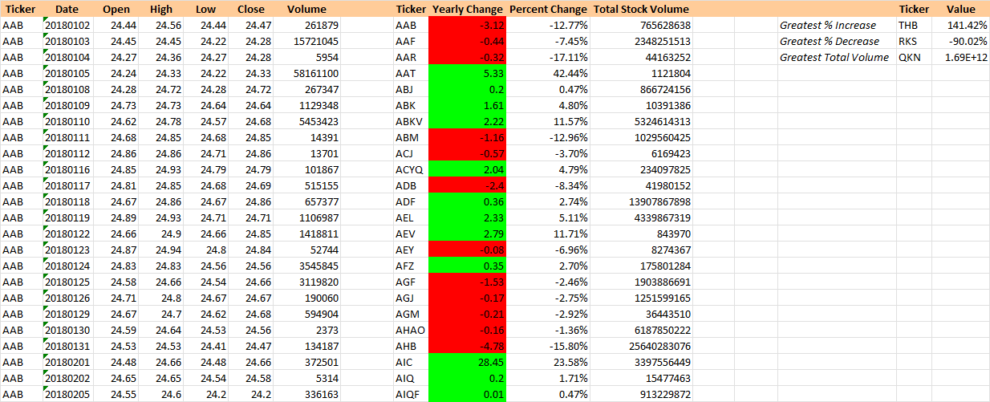

* **2019 Stock Market Data – Results Screenshot**

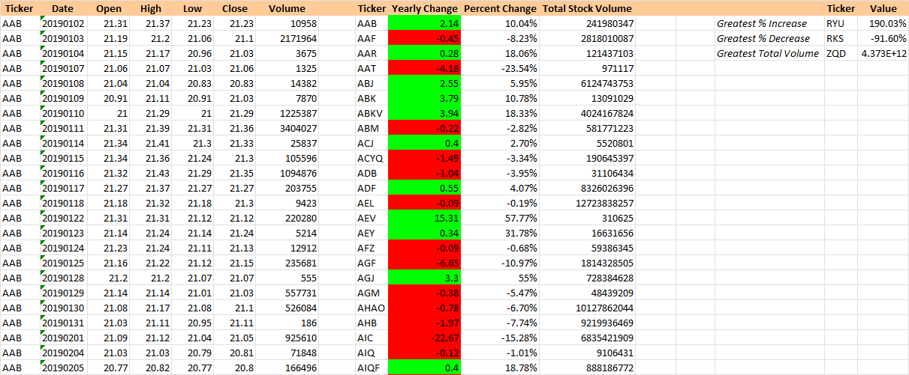

* **2020 Stock Market Data - Results Screenshot**

